Project Design Phase-II
Data Flow Diagram & User Stories

Date | 26 January 2026
Team ID | 69c1028d4241397902eb7b26
Project Name | Automating Data Import and Relationship Mapping Using Import Sets & Dot Walking
Maximum Marks | 4 Marks

Data Flow Diagrams:
Stage 1 — Awareness: Admin receives request to import 500+ employee records from HR Excel sheet into ServiceNow CMDB/HR tables. Realizes manual entry is not feasible. Stage 2 — Exploration: Admin explores ServiceNow Import Sets module. Discovers staging tables, transform maps, and field mapping options. Stage 3 — Setup: Admin uploads Excel file → Import Set table auto-created → Creates Transform Map → Maps fields manually → Runs transform. Stage 4 — Problem Encountered: Reference fields (like Department, Location) fail to map because they require dot walking across related tables. Duplicates are created.
Example: DFD Level 0 (Industry Standard)
Example: (Simplified)
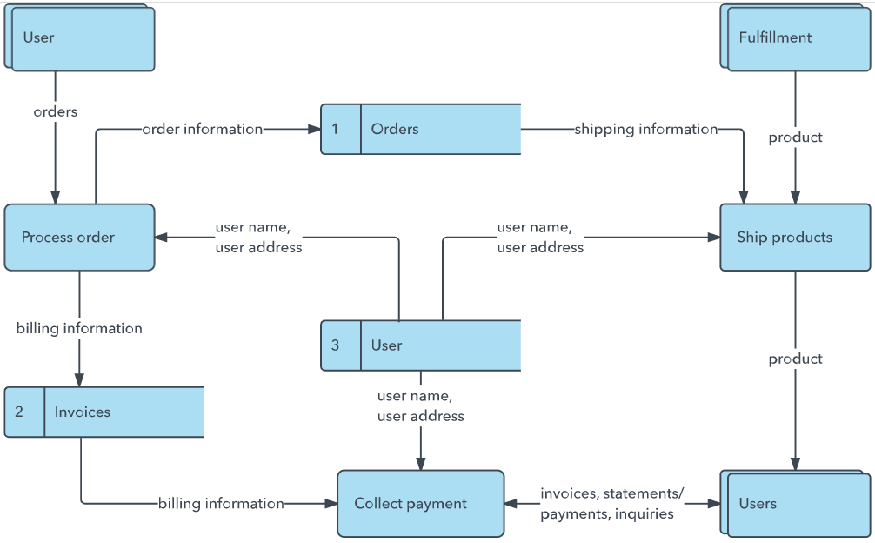


User Stories
Use the below template to list all the user stories for the product.
User Type | Functional Requirement (Epic) | User Story Number | User Story / Task | Acceptance criteria | Priority | Release
Customer (Mobile user) | Registration | USN-1 | As a user, I can register for the application by entering my email, password, and confirming my password. | I can access my account / dashboard | High | Sprint-1
 |  | USN-2 | As a user, I will receive confirmation email once I have registered for the application | I can receive confirmation email & click confirm | High | Sprint-1
 |  | USN-3 | As a user, I can register for the application through Facebook | I can register & access the dashboard with Facebook Login | Low | Sprint-2
 |  | USN-4 | As a user, I can register for the application through Gmail |  | Medium | Sprint-1
 | Login | USN-5 | As a user, I can log into the application by entering email & password |  | High | Sprint-1
 | Dashboard
Customer (Web user)
Customer Care Executive
Administrator

